CHAPTER 1
INTRODUCTION
1.1 Introduction
An autonomous robot is a robot that is designed and engineered to deal with its environment on its own, and work for extended periods of time without human intervention. Autonomous robots often have sophisticated features that can help them to understand their physical environment and automate parts of their maintenance and direction that used to be done by human hands. Autonomous robots typically go about their work without any human interaction unless that human interaction is necessary as part of their task.
Autonomous robots are intelligent machines capable of performing tasks in the world by themselves, without explicit human control. Examples range from autonomous helicopters to Roomba, the robot vacuum cleaner.

Many tasks which are beyond human ability can be performed with the help of robotics and robotics in the war will be very helpful in its operation. The advancement of robot technology will be amazing and today, robots can be seen virtually in all the fields from transport to health, and recreation to industries. The use of this technology will get proclamations from society for taking away the jobs of an ordinary man. But to solve the issues related to this the usage of robots should be applied to selected tasks and mostly be used in the areas where a human cannot reach or is not capable of performing.
Autonomous vehicle technologies are receiving great attention with increasing demands for autonomy for both civilian and military purposes. In addition, advanced perception techniques and the capability to locate obstacles and targets are necessary to properly operate autonomous systems. Moreover, achieve reliable levels of performance by determining the faults and enabling the system to operate with these faults in mind. Fault tolerance is required to analyze the measured input/output signals of the system.
Autonomous vehicles have become increasingly important assets in various civilian and military operations due to their capability for automatic navigation. These vehicles are able to operate and react to their environment without any outside controls. Autonomous vehicles offer numerous key advantages within the modern world.

1.2 Electrical Aspect
There are many types of robots; they are used in many different environments and for many different uses. Although being very diverse in application and form, they all share three basic similarities when it comes to their construction:
- Robots all have some kind of mechanical construction, a frame, form or shape designed to achieve a particular task. For example, a robot designed to travel across heavy dirt or mud, might use caterpillar tracks. The mechanical aspect is mostly the creator's solution to completing the assigned task and dealing with the physics of the environment around it. Form follows function.
- Robots have electrical components that power and control the machinery. For example, the robot with caterpillar tracks would need some kind of power to move the tracker treads. That power comes in the form of electricity, which will have to travel through a wire and originate from a battery, a basic electrical circuit. Even petrol powered machines that get their power mainly from petrol still require an electric current to start the combustion process which is why most petrol powered machines like cars, have batteries. The electrical aspect of robots is used for movement (through motors), sensing (where electrical signals are used to measure things like heat, sound, position, and energy status) and operation (robots need some level of electrical energy supplied to their motors and sensors in order to activate and perform basic operations)
- All robots contain some level of computer programming code. A program is how a robot decides when or how to do something. In the caterpillar track example, a robot that needs to move across a muddy road may have the correct mechanical construction and receive the correct amount of power from its battery, but would not go anywhere without a program telling it to move. Programs are the core essence of a robot, it could have excellent mechanical and electrical construction, but if its program is poorly constructed its performance will be very poor (or it may not perform at all). There are three different types of robotic programs: remote control, artificial intelligence and hybrid. A robot with remote control programming has a preexisting set of commands that it will only perform if and when it receives a signal from a control source, typically a human being with a remote control. It is perhaps more appropriate to view devices controlled primarily by human commands as falling in the discipline of automation rather than robotics. Robots that use artificial intelligence interact with their environment on their own without a control source, and can determine reactions to objects and problems they encounter using their preexisting programming. Hybrid is a form of programming that incorporates both AI and RC functions in them.

1.3 Scope of Robots:
The advance version of machines are robots which are used to do advanced tasks and are programmed to make decisions on their own. When a robot is designed the most important thing to be kept in mind is that What the function is to be performed and what are the limitations of the robot. Each robot has a basic level of complexity and each of the levels has the scope which limits the functions that are to be performed. For general basic robots, their complexity is decided by the number of limbs, actuators and the sensors that are used while for advanced robots the complexity is decided by the number of microprocessors and microcontroller used. As increasing any component in the robot, it is increasing the scope of the robot and with every joint added, the degree of the robot is enhanced.

Advantages:

The advantages of using robots are given below:
- They can get information that a human can’t get.
- They can perform tasks without any mistakes and very efficiently and fast.
- Maximum robots are automatic, so they can perform different tasks without needing human interaction.
- Robots are used in different factories to produce items like plane, car parts etc.
- They can be used for mining purposes and can be sent to earth’s madrid.
- Safety. Safety is the most obvious advantage of utilizing robotics.
- Speed. Robots don't get distracted or need to take breaks.
- Consistency Robots never need to divide their attention between a multitude of things.
- Perfection.
- Happier Employees.
- Job Creation.
- Productivity.

Limitations:

The disadvantages of using robots are given below:
- They need the power supply to keep going. People working in factories may lose their jobs as robots can replace them.
- They need high maintenance to keep them working all day long. And the cost of maintaining the robots can be expensive.
- They can store huge amount of data but they are not as efficient as our human brains.
- As we know that robots work on the program that has been installed in them. So other than the program installed, robots can’t do anything different.
- The most important disadvantage is that if the program of robots comes in wrong hands they can cause the huge amount of destruction.

Applications:
As more and more robots are designed for specific tasks, this method of classification becomes more relevant. For example, many robots are designed for assembly work, which may not be readily adaptable for other applications.. Caterpillar plans which is aiming to develop remote-controlled machines and are expecting to develop heavy robots by 2021.
    - Agricultural robots.
    - Household robots.
    - Domestic robots.
    - Nano robots.
    - Swarm robots.

CHAPTER 2
LITERATURE SURVEY
The history of robots has its origins in the ancient world. Concepts akin to a robot can be found as long ago as the 4th century BC when the Greek mathematician Archytas of Tarentum postulated a mechanical bird he called “The Pigeon”, which was propelled by steam.
The first electronic autonomous robots with complex behavior were created by William Grey Walter of the Burden Neurological Institute at Bristol, England in 1948 and 1949.
The first digitally operated and programmable robot was invented by George Devol in 1954 and was ultimately called the Unimate. This later laid the foundations of the modern robotics industry. Devol sold the first Unimate to General Motors in 1960, and it was installed in 1961 in a plant in Trenton, New Jersey to lift hot pieces of metal from a die casting machine and stack them. Devol’s patent for the first digitally operated programmable robotic arm represents the foundation of the modern robotics industry.
The first mobile robot capable of reasoning about its surroundings, Shakey, was built in 1970 by the Stanford Research Institute. Shakey combined multiple sensor inputs, including TV cameras, laser rangefinders, and bump sensors to navigate.
The biomimetic robot RoboTuna was built by doctoral student David Barrett at the Massachusetts Institute of Technology in 1996 to study how fish swim in water. RoboTuna is designed to float and to resemble a bluefin tuna.
In 1999, Sony introduced the AIBO, a robotic dog capable of interacting with humans; the first models released in Japan sold out in 20 minutes. Honda revealed the most advanced result of their humanoid project in 2000, named ASIMO. ASIMO can run, walk, communicate with humans, recognize faces, environment, voices, and posture, and interact with its environment. The popular Roomba, a robotic vacuum cleaner, was first released in 2002 by the company iRobot.
On October 25, 2017, at the Future Investment Summit in Riyadh, a robot called Sophia was granted Saudi Arabian citizenship, becoming the first robot ever to have a nationality.

Autonomous vehicle technologies are receiving great attention with increasing demands for autonomy for both civilian and military purposes. In addition, advanced perception techniques and the capability to locate obstacles and targets are necessary to properly operate autonomous systems. Moreover, achieve reliable levels of performance by determining the faults and enabling the system to operate with these faults in mind. Fault tolerance is required to analysing the measured input/output signals of the system.
Autonomous vehicles have become increasingly important assets in various civilian and military operations due to their capability for automatic navigation. These vehicles are able to operate and react to their environment without any outside controls. Autonomous vehicles offer numerous key advantages within the modern world. They can function during the daytime and at night when risky missions are involved (compared with manned ground vehicles). In the last decade, significant innovations have taken place in the field of autonomous vehicles and for unmanned ground vehicles (UGVs) in particular. Autonomous vehicle navigation is especially difficult due to several obstacles including bad weather.
Vision-based autonomous navigation has mostly been enhanced for autonomous-based ground vehicles. The use of vision is very essential in solving problems involving autonomous navigation and localization
Types of robots

- Pre-Programmed Robots
- Humanoid Robots.
- Autonomous Robots.
- Teleoperated Robots.
- Augmenting Robots.

CHAPTER 3
EXISTING AND PROPOSED METHODS
3.1 Existing Method
Line Following is one of the most important aspects of robotics. A Line Following Robot is an autonomous robot which is able to follow either a black or white line that is drawn on the surface consisting of a contrasting color. It is designed to move automatically and follow the made plot line. The robot uses several sensors to identify the line thus assisting the robot to stay on the track. The array of four sensor makes its movement precise and flexible. The robot is driven by DC gear motors to control the movement of the wheels. The Arduino Uno interface is used to perform and implement algorithms to control the speed of the motors, steering the robot to travel along the line smoothly. This project aims to implement the algorithm and control the movement of their robot by proper tuning of the control parameters and thus achieve better performance. In addition the LCD interface is added in order to display the distance travelled by the robot. It can be used industrial automated equipment carriers, small household applications, tour guides in museums and other similar applications, etc.

3.1.1 Line Follower Robot Circuit
Following is the complete circuit diagram of the line follower robot. Switch can be connected in series with the battery before it provides power to the board and other components of the line follower robot.
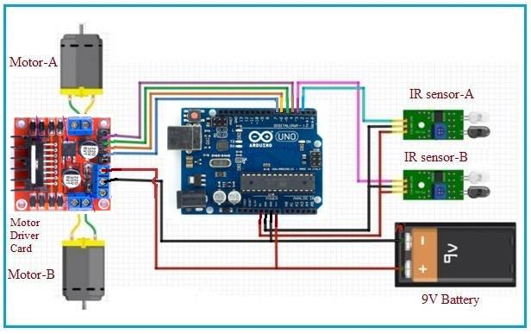
Fig 3.1 : Line Follower Robot Circuit

3.1.2 Line Follower Robot working
IR sensors are used to detect the obstacles. This robot uses IR sensors. This line follower robot is designed to follow the black line by detecting white background and stops when it finds black background. The same is demonstrated in the video below.
IR sensors provide output as zero or one based on presence of obstacle. In this case it provides output based on black or non black (i.e. white) color. When there is black color, output is one and as per arduino code it stops the motor driver output and consecutively motors are OFF. When there is white color in front of IR sensors, output is zero and as per code it generates motor driver output and consecutively motors are ON and robot moves forward due to movement of wheels.

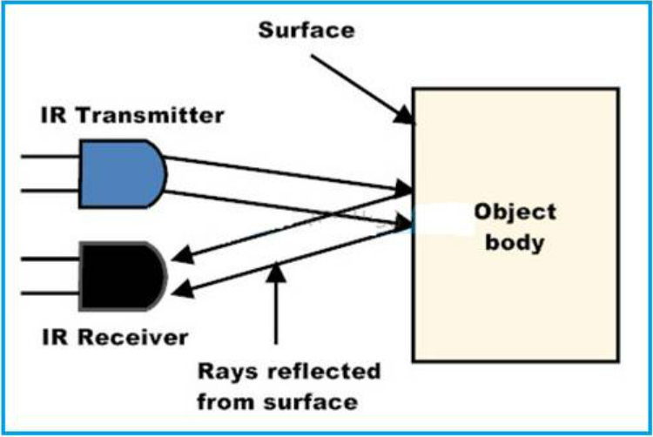
Fig 3.2 :Working of IR Sensor

3.2 Proposed Method
Proposed method is an advanced version of the existing method. The current method the robot works autonomously with out using using any sensors or navigation system on the robot. The automated guided vehicle runs independently with out any human intervention. A single camera is used on the top of the robot to detect the robot. Here, the on demand technique image processing is used to detect the robot from camera.
We have used python script with open cv to track the robot with colour and used mathematics formulas to triangulate the colour boxes on the robot to find the position and orientation of the robot. There after we have used the python requests module to send the respective commands to navigate the robot from the pc.
There after we have used the python requests module to send the respective commands to navigate the robot from the pc.
Single camera is used to track the robots. The pc will send the commands to Robot through wifi.

3.2.1 Functional Block Diagram
Camera
Servo Motor
motor
Arduino Uno Wi-Fi Rev2 Board

Micro Gear Motor
Laptop
Motor Driver Shield

Fig 3.3 : Block Diagram

CHAPTER 4
MAJOR COMPONENTS

HARDWARE REQUIREMENTS

    - Arduino Uno Wi-Fi Rev2 Board

    - Servo Motor

    - Webcam

    - DC Motor

    - Rechargeable Battery

    - Motor Driver Shield

    - USB

SOFTWARE REQUIREMENTS

    - Arduino IDE Compiler

    - Python Programming Language

4.1 Arduino Uno Wi-Fi Rev 2 Board
The Arduino UNO WiFi Rev2 is the easiest point of entry to basic IoT with the standard form factor of the UNO family. Whether you are looking at building a sensor network connected to your office or home router, or if you want to create a Bluetooth Low Energy device sending data to a cell phone, the Arduino UNO WiFi Rev2 is your one-stop-solution for many of the basic IoT application scenarios.
Add this board to a device and you'll be able to connect it to a WiFi network, using its secure ECC608 crypto chip accelerator. The Arduino Uno WiFi is functionally the same as the Arduino Uno Rev3, but with the addition of WiFi / Bluetooth and some other enhancements.

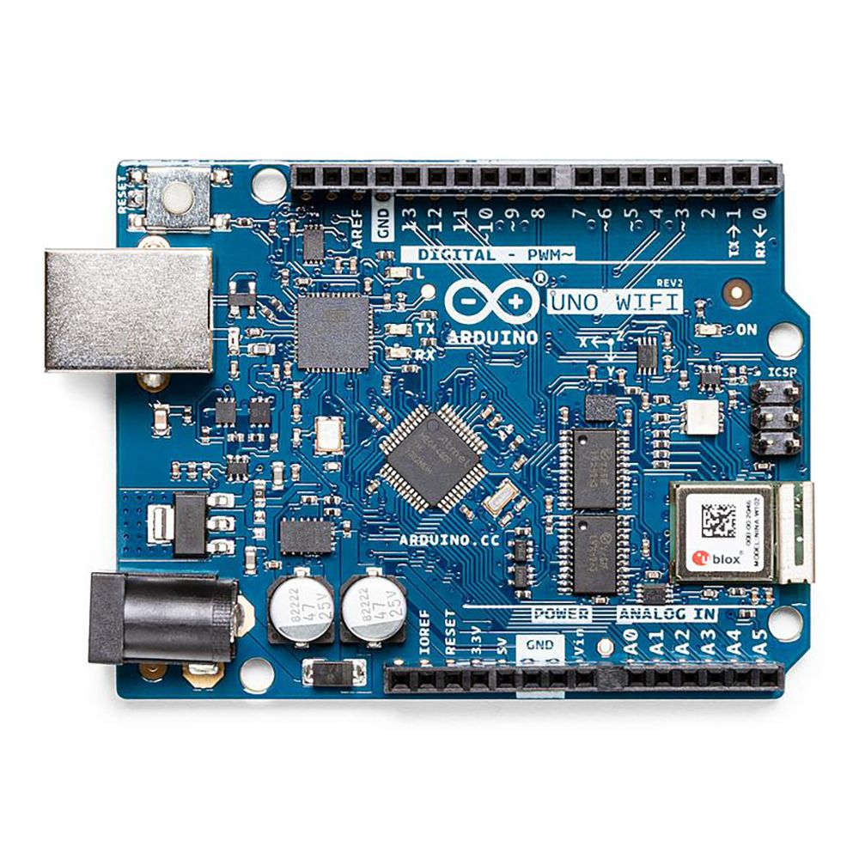
Fig 4.1 : Arduino Uno Wi-Fi Rev 2 Board

The Wi-Fi Module is a self-contained SoC with an integrated TCP/IP protocol stack that can provide access to a Wi-Fi network, or act as an access point. Whether you are looking at building a sensor network connected to your office or home router, or if you want to create a BLE device sending data to a cell phone, the Arduino UNO Wi-Fi Rev.2 is your one-stop-solution for many of the basic IoT application scenarios.
The Arduino UNO Wi-Fi Rev2 has 14 digital input/output pins—5 can be used as PWM outputs—6 analog inputs, a USB connection, a power jack, an ICSP header, and a reset button. It contains everything needed to support the microcontroller. Simply connect it to a computer with a USB cable or power it with an AC adapter or battery to get started.

4.1.1 Details
Add this board to a device and you'll be able to connect it to a WiFi network, using its secure ECC608 crypto chip accelerator. The Arduino Uno WiFi is functionally the same as the Arduino Uno Rev3, but with the addition of WiFi / Bluetooth and some other enhancements. It incorporates the brand new ATmega4809 8-bit microcontroller from Microchip and has an onboard IMU (Inertial Measurement Unit) LSM6DS3TR.
The Wi-Fi Module is a self-contained SoC with an integrated TCP/IP protocol stack that can provide access to a Wi-Fi network, or act as an access point.
The Arduino UNO WiFi Rev.2 has 14 digital input/output pins—5 that can be used as PWM outputs—6 analog inputs, a USB connection, a power jack, an ICSP header, and a reset button. It contains everything needed to support the microcontroller. Simply connect it to a computer with a USB cable or power it with an AC adapter or battery to get started.

4.1.2 Specifications
Attribute | Value
Product Name | UNO WiFi Rev 2
Processor Part Number | ATmega4809
Revision | V2

4.1.3 Details of Arduino Uno Wi-Fi Rev2 Board
Microcontroller | ATmega4809
Operating Voltage | 5V
Input Voltage (Recommended) | 7V – 12V
Digital I/O Pins | 14 – 5 Provide PWM Output
PWM Digital I/O Pins | 5
Analog Input Pins | 6
DC Current Per I/O Pin | 20mA
DC Current For 3.3V Pin | 50mA
Flash Memory | 48 KB (ATmega4809)
SRAM | 6,144 Bytes (ATmega4809)
EEPROM | 256 Bytes (ATmega4809)
Clock Speed | 16 MHz
Radio Module | u-blox NINA-W102
Secure Element | ATECC608A
Internal Measuring Unit | LMS6DS3TR
LED_BUILTIN | 25
Length | 68.8 mm
Width | 53.4 mm
Weight | 25 g
The Arduino Uno WiFi Rev2 is an Arduino Uno with an integrated WiFi module. The board is based on the Microchip MEGA4809 with an ESP32 u-blox NINA-W13 WiFi Module integrated. The NINA-W13 Module is a self-contained SoC with an integrated TCP/IP protocol stack that can give access to your WiFi network (or the device can act as an access point). The Arduino Uno WiFi Rev2 is programmed using the Arduino Software (IDE).

4.1.4 Use of Arduino Uno WiFi Rev2
With the Arduino WiFi Shield, this library allows an Arduino board to connect to the internet and to read and write an SD card using the SD library. It can serve as either a server accepting incoming connections or a client making outgoing ones. The library supports WEP and WPA2 Personal encryption, but not WPA2 Enterprise.The WiFI library is similar to the Ethernet library and many of the function calls are the same.
4.1.5 Applications of Arduino Uno Wi-Fi Shield
1. IOT Applications
2. Robotics
3. Home applications
4.2 Servo Motor
A servomotor is a linear actuator or rotary actuator that allows for precise control of linear or angular position, acceleration, and velocity. It consists of a motor coupled to a sensor for position feedback. It also requires a servo drive to complete the system. The drive uses the feedback sensor to precisely control the rotary position of the motor.It also requires a relatively sophisticated controller, often a dedicated module designed specifically for use with servomotors.
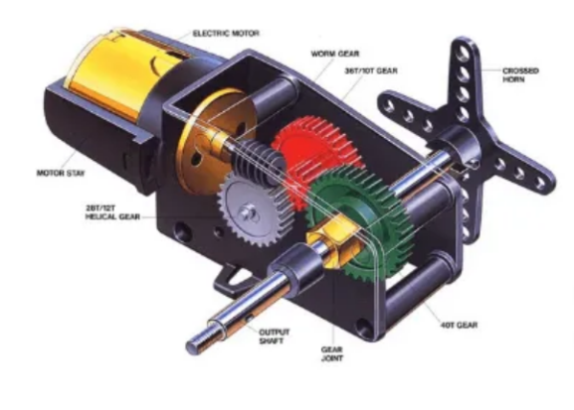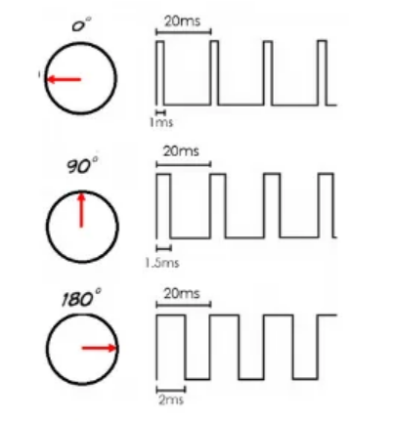
Fig 4.2 :Servo Motor Fig 4.3 :Timing Diagram

4.2.1 Servo Motor Theory

There are some special types of applications of an electric motor where the rotation of the motor is required for just a certain angle. For these applications, we require some special types of motor with some special arrangement which makes the motor rotate a certain angle for a given electrical input (signal). For this purpose, servo motor comes into the picture.
The servo motor is usually a simple DC motor controlled for specific angular rotation with the help of additional servomechanism (a typical closed-loop feedback control system). Nowadays, servo systems are used widely in industrial applications.
Servo motor applications are also commonly seen in remote-controlled toy cars for controlling the direction of motion, and it is also very widely used as the motor which moves the tray of a CD or DVD player. Besides these, there are hundreds of servo motor applications we see in our daily life.
The main reason behind using a servo is that it provides angular precision, i.e. it will only rotate as much we want and then stop and wait for the next signal to take further action. The servo motor is unlike a standard electric motor which starts turning as when we apply power to it, and the rotation continues until we switch off the power. We cannot control the rotational progress of electrical motor, but we can only control the speed of rotation and can turn it ON and OFF. Small servo motors are included many beginner Arduino starter kits, as they are easy to operate as part of a small electronics projects.

4.2.2. Servo Motor Working Mechanism
It consists of three parts:
- Controlled device
- Output sensor
- Feedback system
It is a closed-loop system where it uses a positive feedback system to control motion and the final position of the shaft. Here the device is controlled by a feedback signal generated by comparing output signal and reference input signal.
Here reference input signal is compared to the reference output signal and the third signal is produced by the feedback system. And this third signal acts as an input signal to the control the device. This signal is present as long as the feedback signal is generated or there is a difference between the reference input signal and reference output signal. So the main task of servomechanism is to maintain the output of a system at the desired value at presence of noises.
4.2.3 Servo Motor Working Principle
A servo consists of a Motor (DC or AC), a potentiometer, gear assembly, and a controlling circuit. First of all, we use gear assembly to reduce RPM and to increase torque of the motor. Say at initial position of servo motor shaft, the position of the potentiometer knob is such that there is no electrical signal generated at the output port of the potentiometer. Now an electrical signal is given to another input terminal of the error detector amplifier. Now the difference between these two signals, one comes from the potentiometer and another comes from other sources, will be processed in a feedback mechanism and output will be provided in terms of error signal. This error signal acts as the input for motor and motor starts rotating. Now motor shaft is connected withthe potentiometer and as the motor rotates so the potentiometer and it will generate a signal. So as the potentiometer’s angular position changes, its output feedback signal changes.

4.2.4 Interfacing of Servo Motor With Microcontrollers
Interfacing hobby Servo motors like s90 servo motor with MCU is very easy. Servos have three wires coming out of them. Out of which two will be used for Supply (positive and negative) and one will be used for the signal that is to be sent from the MCU. An MG995 Metal Gear Servo Motor which is most commonly used for RC cars humanoid bots etc. The picture of MG995 is shown below:
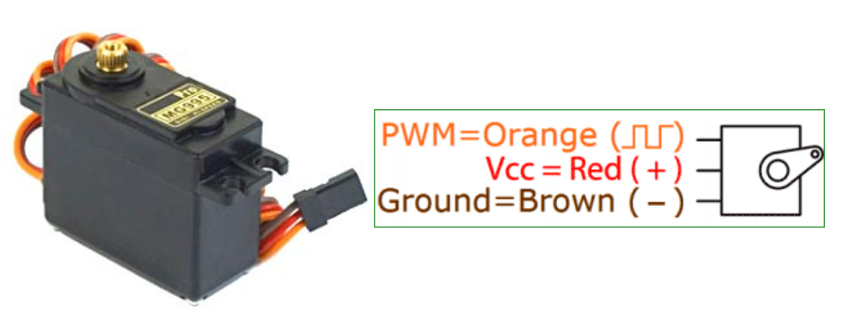
Fig 4.4 : Connections of Servo Motor
The color coding of your servo motor might differ hence check for your respective datasheet. All servo motors work directly with your +5V supply rails but we have to be careful on the amount of current the motor would consume if you are planning to use more than two servo motors a proper servo shield should be designed.
4.2.5 Controlling of Servo Motor
All motors have three wires coming out of them. Out of which two will be used for Supply (positive and negative) and one will be used for the signal that is to be sent from the MCU. Servo motor is controlled by PWM (Pulse with Modulation) which is provided by the control wires. There is a minimum pulse, a maximum pulse and a repetition rate. Servo motor can turn 90 degree from either direction form its neutral position. The servo motor expects to see a pulse every 20 milliseconds (ms) and the length of the pulse will determine how far the motor turns. For example, a 1.5ms pulse will make the motor turn to the 90° position, such as if pulse is shorter than 1.5ms shaft moves to 0° and if it is longer than 1.5ms than it will turn the servo to 180°.
Servo motor works on PWM (Pulse width modulation) principle, means its angle of rotation is controlled by the duration of applied pulse to its Control PIN. Basically servo motor is made up of DC motor which is controlled by a variable resistor (potentiometer) and some gears. High speed force of DC motor is converted into torque by Gears. We know that WORK= FORCE X DISTANCE, in DC motor Force is less and distance (speed) is high and in Servo, force is High and distance is less. The potentiometer is connected to the output shaft of the Servo, to calculate the angle and stop the DC motor on the required angle.
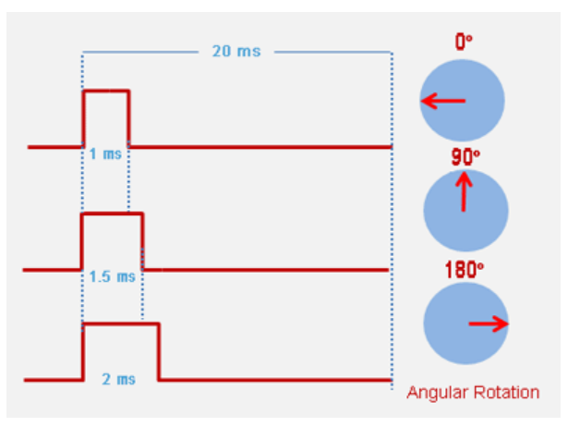
Fig 4.5 : Controlling of Servo Motor
Servo motor can be rotated from 0 to 180 degrees, but it can go up to 210 degrees, depending on the manufacturing. This degree of rotation can be controlled by applying the Electrical Pulse of proper width, to its Control pin. Servo checks the pulse in every 20 milliseconds. The pulse of 1 ms (1 millisecond) width can rotate the servo to 0 degrees, 1.5ms can rotate to 90 degrees (neutral position) and 2 ms pulse can rotate it to 180 degree. All servo motors work directly with your +5V supply rails but we have to be careful about the amount of current the motor would consume if you are planning to use more than two servo motors a proper servo shield should be designed.
All servo motors work directly with your +5V supply rails but we have to be careful about the amount of current the motor would consume if you are planning to use more than two servo motors a proper servo shield should be designed.

4.3 Webcam
A webcam is a video camera that feeds or streams an image or video in real time to or through a computer network, such as the Internet. Webcams are typically small cameras that sit on a desk, attach to a user's monitor, or are built into the hardware. Webcams can be used during a video chat session involving two or more people, with conversations that include live audio and video.
Webcam software enables users to record a video or stream the video on the Internet. As video streaming over the Internet requires much bandwidth, such streams usually use compressed formats. The maximum resolution of a webcam is also lower than most handheld video cameras, as higher resolutions would be reduced during transmission. The lower resolution enables webcams to be relatively inexpensive compared to most video cameras, but the effect is adequate for video chat sessions.^{[1]}
The term "webcam" (a clipped compound) may also be used in its original sense of a video camera connected to the Web continuously for an indefinite time, rather than for a particular session, generally supplying a view for anyone who visits its web page over the Internet. Some of them, for example, those used as online traffic cameras, are expensive, rugged professional video cameras.
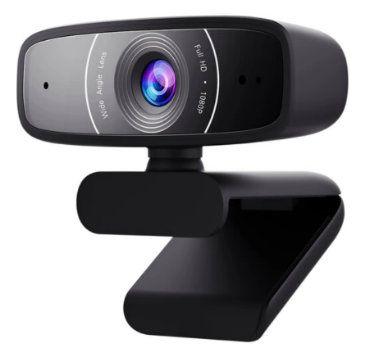
Fig 4.6 : ASUS Webcam C3

4.3.1 Technology
Webcams typically include a lens, an image sensor, support electronics, and may also include one or even two microphones for sound.

4.3.1.1 Image Sensor
Image sensors can be CMOS or CCD, the former being dominant for low-cost cameras, but CCD cameras do not necessarily outperform CMOS-based cameras in the low-price range. Most consumer webcams are capable of providing VGA-resolution video at a frame rate of 30 frames per second. Many newer devices can produce video in multi-megapixel resolutions, and a few can run at high frame rates such as the PlayStation Eye, which can produce 320×240 video at 120 frames per second. The Wii Remote contains an image sensor with a resolution of 1024×768 pixels. Common resolutions of laptops' built-in webcams are 720p (HD), and in lower-end laptops 480p.^{[2]} The earliest known laptops with 1080p (Full HD) webcams like the Samsung 700G7C were released in the early 2010s.^{[3]}
As the bayer filter is proprietary, any webcam contains some built-in image processing, separate from compression.
4.3.1.2 Optics
Various lenses are available, the most common in consumer-grade webcams being a plastic lens that can be manually moved in and out to focus the camera. Fixed-focus lenses, which have no provision for adjustment, are also available.
4.3.1.3 Compression
Digital video streams are represented by huge amounts of data, burdening its transmission (from the image sensor, where the data is continuously created) and storage alike. Most if not all cheap webcams come with built-in ASIC to do video compression in real-time. Support electronics read the image from the sensor and transmit it to the host computer. The camera pictured to the right, for example, uses a Sonix SN9C101 to transmit its image over USB. Typically, each frame is transmitted uncompressed in RGB or YUV or compressed as JPEG. Some cameras, such as mobile-phone cameras, use a CMOS sensor with supporting electronics "on die", i.e. the sensor and the support electronics are built on a single silicon chip to save space and manufacturing costs.

4.3.1.4 Interface
Typical interfaces used by articles marketed as a "webcam" are USB, Ethernet and IEEE 802.11 (denominated as IP camera). Further interfaces such as e.g. Composite video, S-Video or FireWire were also available.
The USB video device class (UVC) specification allows inter-connectivity of webcams to computers without the need for proprietary device drivers.
4.3.1.5 Software
Various proprietary as well as free and open-source software is available to handle the UVC stream. One could use Guvcview or GStreamer and GStreamer-based software to handle the UVC stream. Another could use multiple USB cameras attached to the host computer the software resides on, and broadcast multiple streams at once over (Wireless) Ethernet, such as MotionEye. MotionEye can either be installed onto a Raspberry Pi as MotionEyeOs, or afterwards on Raspbian as well. MotionEye can also be set up on Debian, Raspbian is a variant of Debian. Note that MotionEye V4.1.1 ( Aug '21 ) can only run on Debian 10 Buster ( oldstable ) and Python 2.7. Newer versions such as 3.X are not supported at this point of time according to Ccrisan, foundator and author of MotionEye.
4.3.2 Characteristics
Webcams are known for their low manufacturing cost and their high flexibility, making them the lowest-cost form of videotelephony. As webcams evolved simultaneously with display technologies, USB interface speeds and broadband internet speeds, the resolution went up from gradually from 320×240, to 640×480, and some now even offer 1280×720 (aka 720p) or 1920×1080 (aka 1080p) resolution.
Webcams can come with different presets and Fields of View (FOV). Individual users can make use of less than 90° Horizontal FOV for home offices and live streaming. Webcams with as much as 360° Horizontal FOV can be used for small- to medium- sized rooms (sometimes even large rooms). Depending on the users' purposes, webcams in the market can display the whole room or just the general vicinity.
Despite the low cost, the resolution offered as of 2019 is impressive, with now the low-end webcams offering resolutions of 720p, mid-range webcams offering 1080p resolution, and high-end webcams offering 4K resolution at 60 fps.
Webcams have become a source of security and privacy issues, as some built-in webcams can be remotely activated by spyware. To address this concern, many webcams come with a physical lens cover.
4.3.3 Uses
The most popular use of webcams is the establishment of video links, permitting computers to act as videophones or videoconference stations. For example, Apple's iSight camera, which is built into Apple laptops, iMacs and a majority of iPhones, can be used for video chat sessions, using the Messages instant messaging program. Other popular uses include security surveillance, computer vision, video broadcasting, and for recording social videos.
The video streams provided by webcams can be used for a number of purposes, each using appropriate software.

4.3.3.1 Video monitoring
Webcams may be installed at places such as childcare centres, offices, shops and private areas to monitor security and general activity.

4.3.3.2 Commerce
Webcams have been used for augmented reality experiences online. One such function has the webcam act as a "magic mirror" to allow an online shopper to view a virtual item on themselves. The Webcam Social Shopper is one example of software that utilizes the webcam in this manner.

4.3.3.3 Video calling and video conferencing
Webcams can be added to instant messaging, text chat services such as AOL Instant Messenger, and VoIP services such as Skype, one-to-one live video communication over the Internet has now reached millions of mainstream PC users worldwide. Improved video quality has helped webcams encroach on traditional video conferencing systems. New features such as automatic lighting controls, real-time enhancements, automatic face tracking and autofocus, assist users by providing substantial ease-of-use, further increasing the popularity of webcams.
Since the middle of 2020, remote and hybrid work has increased the popularity of webcams. Businesses, schools, and individuals have relied on video conferencing instead of spending on business travel for meetings. Moreover, the number of video conferencing cameras and software have multiplied since then due to their popularity. Webcam features and performance can vary by program, computer operating system, and also by the computer's processor capabilities. Video calling support has also been added to several popular instant messaging programs.

4.3.3.4 Video security
Webcams can be used as security cameras. Software is available to allow PC-connected cameras to watch for movement and sound, recording both when they are detected. These recordings can then be saved to the computer, e-mailed, or uploaded to the Internet. In one well-publicised case, a computer e-mailed images of the burglar during the theft of the computer, enabling the owner to give police a clear picture of the burglar's face even after the computer had been stolen. Unauthorized access of webcams can present significant privacy issues (see "Privacy" section below). In December 2011, Russia announced that 290,000 Webcams would be installed in 90,000 polling stations to monitor the 2012 Russian presidential election.

4.3.3.5 Video clips and stills
Webcams can be used to take video clips and still pictures. Various software tools in wide use can be employed for this, such as PicMaster and Microsoft's Camera app (for use with Windows operating systems), Photo Booth (Mac), or Cheese (with Unix systems). For a more complete list see Comparison of webcam software.

4.3.3.6 Input control devices
Special software can use the video stream from a webcam to assist or enhance a user's control of applications and games. Video features, including faces, shapes, models and colors can be observed and tracked to produce a corresponding form of control. For example, the position of a single light source can be tracked and used to emulate a mouse pointer, a head-mounted light would enable hands-free computing and would greatly improve computer accessibility. This can be applied to games, providing additional control, improved interactivity and immersiveness.
FreeTrack is a free webcam motion-tracking application for Microsoft Windows that can track a special head-mounted model in up to six degrees of freedom and output data to mouse, keyboard, joystick and FreeTrack-supported games. By removing the IR filter of the webcam, IR LEDs can be used, which has the advantage of being invisible to the naked eye, removing a distraction from the user. TrackIR is a commercial version of this technology.
The EyeToy for the PlayStation 2, PlayStation Eye for the PlayStation 3, and the Xbox Live Vision camera and Kinect motion sensor for the Xbox 360 and are color digital cameras that have been used as control input devices by some games. Small webcam-based PC games are available as either standalone executables or inside web browser windows using Adobe Flash.

4.3.3.7 Astro photography
With very-low-light capability, a few specific models of webcams are very popular to photograph the night sky by astronomers and astro photographers. Mostly, these are manual-focus cameras and contain an old CCD array instead of comparatively newer CMOS array. The lenses of the cameras are removed and then these are attached to telescopes to record images, video, still, or both. In newer techniques, videos of very faint objects are taken for a couple of seconds and then all the frames of the video are "stacked" together to obtain a still image of respectable contrast.

4.3.3.8 Laser beam profiling
A webcam's CCD response is linear proportional to the incoming light. Therefore, webcams are suitable to record laser beam profiles, after the lens is removed. The resolution of a laser beam profiler depends on the pixel size. Commercial webcams are usually designed to record color images. The size of a webcam's color pixel depends on the model and may lie in the range of 5 to 10 µm. However, a color pixel consists of four black and white pixels each equipped with a color filter (for details see Bayer filter). Although these color filters work well in the visible, they may be rather transparent in the near infrared. By switching a webcam into the Bayer-mode it is possible to access the information of the single pixels and a resolution below 3 µm was possible.

Gear Motor

Introduction
A gear motor is any electric motor coupled with a gear train. Gear motors use either AC (Alternating Current) or DC (Direct Current) power. In most cases, the gear reducer is intended to multiply the available output torque without increasing the power consumption of the motor while maintaining a compact size. The trade off for torque multiplication is a proportional reduction in the speed of the output shaft, and reduced overall efficiency. By utilizing the proper gear technology and ratio for specific applications, the optimal output and speed profiles can be obtained along with the perfect mechanical fit to unlock the maximum value of your OEM equipment.
A gearmotor, also called a gear motor or a geared motor, is a combination of a gear system or gearbox and an electric motor. When asking yourself “what is a gear motor” or “what is a geared motor,” you are actually probably wondering how a gearmotor can be useful for your company's products or production facility. Geared motors are efficient because you will only have to mount and operate one system, instead of several. Sometimes inaccurately called “gears motors,” or even geared motors, gearmotors generally combine an efficient motor, such as an Electrically Commutated Motor, with a gear reducer or gearhead. These motor gear combinations are a great way to minimize alignment issues with your motor and its gearbox. You don't need to be worried about separately sourcing gears for motors; instead, you can work with a motor and gear in one: a gear drive motor.
A gear motor develops torque due to hydraulic pressure acting against the area of one tooth. There are two teeth trying to move the rotor in the proper direction, while one net tooth at the center mesh tries to move it in the opposite direction. In the design of a gear motor, one of the gears is keyed to an output shaft, while the other is simply an idler gear. Pressurized oil is sent to the inlet port of the motor.
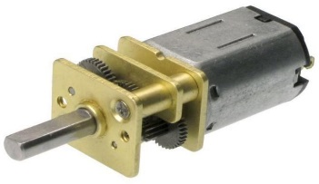
Most of the gear motors are bidirectional. Reversing the direction of flow can reverse the direction of rotation. As in the case of gear pumps, volumetric displacement is fixed. Due to the high pressure at the inlet and low pressure at the outlet, a large side load on the shaft and bearings is produced. Gear motors are normally limited to 150 bar operating pressures and 2500 RPM operating speed. They are available with a maximum flow capacity of 600 LPM.

Fig 4.7 : Basic Gear Motor

The gear motors are simple in construction and have good dirt tolerance, but their efficiencies are lower than those of vane or piston pumps and they leak more than the piston units. Generally,they are not used as servo motors.Hydraulic motors can also be of internal gear
design. These types can operate at higher pressures and speeds and also have greater displacements than external gear motors.
DC gear motors are used primarily in automotive applications such as power winches on trucks, windshield wiper motors and power seat or power window motors. Jacks, cranes, lifts, clamping, robotics, conveyance, and mixing are just some of the applications gearmotors are used for in industry.
Right-angle gear motors, which utilize worm, bevel, or hypoid gearing, and inline gear motors, which employ spur gears or planetary gear systems, are the two most prevalent forms of gear motors. Worm, spur, and planetary gear technologies are the most commonly utilized in Gearmotor designs.

Gear motors are offered with a choice of AC or DC motor types and reduction ratios to accommodate a broad range of applications such as automated door operators, food and beverage machines, and robotics.
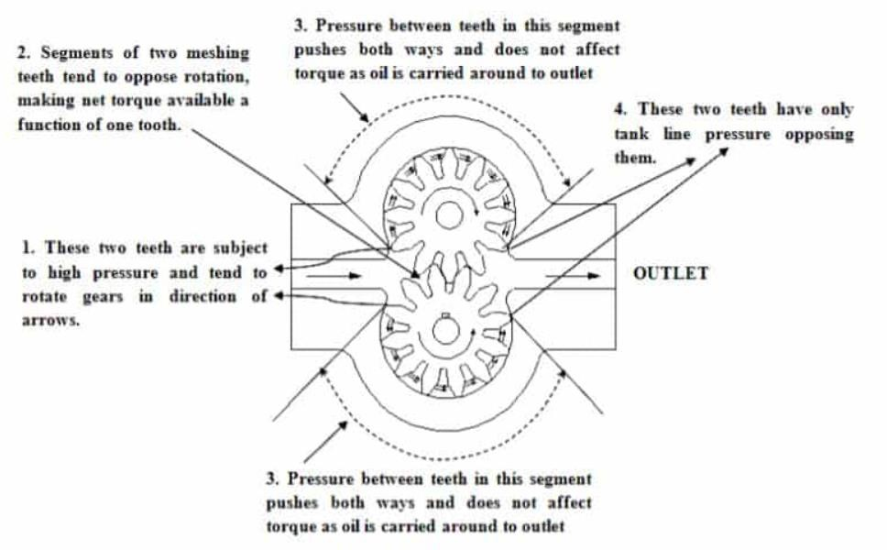

Fig 4.8 :Gear Motor

Applications
Many industrial gear motors are generally fixed-speed AC-powered devices, while variable-speed fixed-gear-ratio motors offer more control. DC gear motors are most commonly used in vehicle industries such as truck power cranes, windscreen wiper motors, plus power seats or power window motors. On the other hand, gear motors are utilized in a variety of industrial applications, including jacks, cranes, elevators, clamping, automation, transportation, and mixing.

        - Packaging, Mixing, Conveyor, Cranes.
        - Industries- Food Processing, Paper, Sugar,
        - High Torque Output.
        - Speed Reduction.
        - High Resolution.
        - Drive Large Inertial Loads.
        - Shorter Positioning Time.
        - Downsize.
        - Improved Damping Characteristics.

4.5 Rechargeable Battery
4.5.1 Rechargeable Battery
A rechargeable battery, storage battery, or secondary cell (formally a type of energy accumulator), is a type of electrical battery which can be charged, discharged into a load, and recharged many times, as opposed to a disposable or primary battery, which is supplied fully charged and discarded after use. It is composed of one or more electrochemical cells. The term "accumulator" is used asit accumulates and stores energy through areversible electrochemical reaction. Rechargeable batteries are produced in many different shapes and sizes, ranging from button cells to megawatt systems connected to stabilize an electrical distribution network. Several different combinations of electrode materials and electrolytes are used, including lead–acid, zinc–air, nickel– cadmium (NiCd), nickel–metal hydride (NiMH), lithium-ion (Li-ion), lithium iron phosphate (LiFePO4), and lithium-ion polymer (Li-ion polymer).
Rechargeable batteries typically initially cost more than disposable batteries, but have a much lower total cost of ownership and environmental impact, as they can be recharged inexpensively many times before they need replacing. Some rechargeable battery types are available in the same sizes and voltages as disposable types, and can be used interchangeably with them. Billions of dollars in research are being invested around the world for improving batteries and industry also focuses on building better batteries
4.5.2 Charging and Discharging
During charging, the positive active material is oxidized, producing electrons, and the negative material is reduced, consuming electrons. These electrons constitute the current flow in the external circuit. The electrolyte may serve as a simple buffer for internal ion flow between the electrodes, as in lithium-ion and nickel- cadmium cells, or it may be an active participant in the electrochemical reaction, as in lead– acid cells.

Fig 4.9 : Rechargeable Battery

4.5.3 Rate of Discharge
Battery charging and discharging rates are often discussed by referencing a "C" rate of current. The C rate is that which would theoretically fully charge or discharge the battery in one hour. For example, trickle charging might be performed at C/20 (or a "20-hour" rate), while typical charging and discharging may occur at C/2 (two hours for full capacity). The available capacity of electrochemical cells varies depending on the discharge rate. Some energy is lost in the internal resistance of cell components (plates, electrolyte, interconnections), and the rate of discharge is limited by the speed at which chemicals in the cell can move about. For lead-acid cells, the relationship between time and discharge rate is described by Peukert's law; a lead-acid cell that can no longer sustain a usable terminal voltage at a high current may still have usable capacity, if discharged at a much lower rate. Data sheets for rechargeable cells often list the discharge capacity on 8-hour or 20-hour or other stated time; cells for uninterruptible power supply systems may be rated at 15-minute discharge.
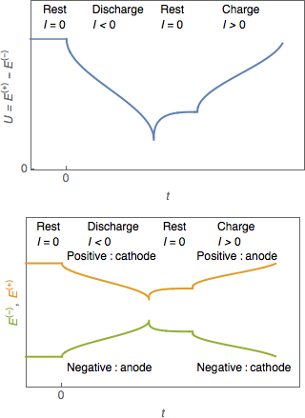
The terminal voltage of the battery is not constant during charging and discharging. Some types have relatively constant voltage during discharge over much of their capacity. Non- rechargeable alkaline and zinc–carbon cells output 1.5V when new, but this voltage drops with use. Most NiMH AA and AAA cells are rated at 1.2 V, but have a flatter than alkaliand can usually be used in equipment designed to use

Fig 4.10 : Battery Recharge and Discharge Time

4.5.4 Damage from Cell Reversal

Subjecting a discharged cell to a current in the direction which tends to discharge it further to the point the positive and negative terminals switch polarity causes a condition called cell reversal. Generally, pushing current through a discharged cell in this way causes undesirable and irreversible chemical reactions to occur, resulting in permanent damage to the cell. Cell reversal can occur under a number of circumstances, the two most common being:

- When a battery or cell is connected to a charging circuit the wrong way around.

- When a battery made of several cells connected in series is deeply discharged.

In the latter case, the problem occurs due to the different cells in a battery having slightly different capacities. When one cell reaches discharge level ahead of the rest, the remaining cells will force the current through the discharged cell.
Many battery-operated devices have a low-voltage cutoff that prevents deep discharges from occurring that might cause cell reversal. A smart battery has voltage monitoring circuitry built inside.
Cell reversal can occur to a weakly charged cell even before it is fully discharged. If the battery drain current is high enough, the cell's internal resistance can create a resistive voltage drop that is greater than the cell's forward emf. This results in the reversal of the cell's polarity while the current is flowing. The higher the required discharge rate of a battery, the better matched the cells should be, both in the type of cell and state of charge, in order to reduce the chances of cell reversal.
In some situations, such as when correcting NiCd batteries that have been previously overcharged, it may be desirable to fully discharge a battery. To avoid damage from the cell reversal effect, it is necessary to access each cell separately: each cell is individually discharged by connecting a load clip across the terminals of each cell, thereby avoiding cell reversal.
4.5.5 Damage during storage in fully discharged state
If a multi-cell battery is fully discharged, it will often be damaged due to the cell reversal effect mentioned above. It is possible however to fully discharge a battery without causing cell reversal—either by discharging each cell separately, or by allowing each cell's internal leakage to dissipate its charge over time.
Even if a cell is brought to a fully discharged state without reversal, however, damage may occur over time simply due to remaining in the discharged state. An example of this is the Sulfation that occurs in lead-acid batteries that are left sitting on a shelf for long periods. For this reason it is often recommended to charge a battery that is intended to remain in storage, and to maintain its charge level by periodically recharging it.
4.5.6 Depth of Discharge
Depth of discharge (DOD) is normally stated as a percentage of the nominal ampere-hour capacity; 0% DOD means no discharge. As the usable capacity of a battery system depends on the rate of discharge and the allowable voltage at the end of discharge, the depth of discharge must be qualified to show the way it is to be measured. Due to variations during manufacture and aging, the DOD for complete discharge can change over time or number of charge cycles. Generally a rechargeable battery system will tolerate more charge/discharge cycles if the DOD is lower on each cycle. Lithium batteries can discharge to about 80 to 90% of their nominal capacity. Lead-acid batteries can discharge to about 50–60%. While flow batteries can discharge 100%.
4.5.7 Lifespan and Cycle Stability
If batteries are used repeatedly even without mistreatment, they lose capacity as the number of charge cycles increases, until they are eventually considered to have reached the end of their useful life. Different battery systems have differing mechanisms for wearing out. For example, in lead-acid batteries, not all the active material is restored to the plates on each charge/discharge cycle; eventually enough material is lost that the battery capacity is reduced. In lithium-ion types, especially on deep discharge, some reactive lithium metal can be formed on charging, which is no longer available to participate in the next discharge cycle. Sealed batteries may lose moisture from their liquid electrolyte, especially if overcharged or operated at high temperature. This reduces the cycling life.

4.5.8 Recharging Time
Recharging time is an important parameter to the user of a product powered by rechargeable batteries. Even if the charging power supply provides enough power to operate the device as well as recharge the battery, the device is attached to an external power supply during the charging time. For electric vehicles used industrially, charging during off-shifts may be acceptable. For highway electric vehicles, rapid charging is necessary for charging in a reasonable time. A rechargeable battery cannot be recharged at an arbitrarily high rate. The internal resistance of the battery will produce heat, and excessive temperature rise will damage or destroy a battery. For some types, the maximum charging rate will be limited by the speed at which active material can diffuse through a liquid electrolyte. High charging rates may produce excess gas in a battery, or may result in damaging side reactions that permanently lower the battery capacity. Very roughly, and with many exceptions and caveats, restoring a battery's full capacity in one hour or less is considered fast charging. A battery charger system will include more complex control-circuit- and charging strategies for fast charging, than for a charger designed for slower recharging.
4.5.9 Active Component
The active components in a secondary cell are the chemicals that make up the positive and negative active materials, and the electrolyte. The positive and negative electrodes are made up of different materials, with the positive exhibiting a reduction potential and the negative having an oxidation potential. The sum of the potentials from these half-reactions is the standard cell potential or voltage.
In primary cells the positive and negative electrodes are known as the cathode and anode, respectively. Although this convention is sometimes carried through to rechargeable systems— especially with lithium-ion cells, because of their origins in primary lithium cells—this practice can lead to confusion.
4.5.10 Types
List of battery types and Comparison of commercial battery types
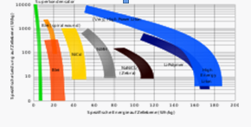
Fig 4.11 : Ragone plot of common types
Common Types
The lead–acid battery, invented in 1859 by French physicist Gaston Planté, is the oldest type of rechargeable battery. Despite having a very low energy-to-weight ratio and a low energy-to-volume ratio, its ability to supply high surge currents means that the cells have a relatively large power-to-weight ratio.

The nickel–cadmium battery (NiCd) was invented by Waldemar Jungner of Sweden in 1899. It uses nickel oxide hydroxide and metallic cadmium as electrodes. Cadmium is a toxic element, and was banned for most uses by the European Union in 2004. Nickel–cadmium batteries have been almost completely superseded by nickel–metal hydride (NiMH) batteries.
The nickel–iron battery (NiFe) was also developed by Waldemar Jungner in 1899; and commercialized by Thomas Edison in 1901 in the United States for electric vehicles and railway signalling. It is composed of only non-toxic elements, unlike many kinds of batteries that contain toxic mercury, cadmium, or lead. The nickel–metal hydride battery (NiMH) became available in 1989. These are now a common consumer and industrial type. The battery has a hydrogen-absorbing alloy for the negative electrode instead of cadmium. The lithium-ion battery was introduced in the market in 1991, is the choice in most consumer electronics, having the best energy density and a very slow loss of charge when not in use. It does have drawbacks too, particularly the risk of unexpected ignition from the heat generated by the battery. Such incidents are rare and according to experts, they can be minimized "via appropriate design, installation, procedures and layers of safeguards" so the risk is acceptable.
Lithium-ion polymer batteries (LiPo) are light in weight, offer slightly higher energy density than Li-ion at slightly higher cost, and can be made in any shape. They are available but have not displaced Li-ion in the market. A primary use is for LiPo batteries is in powering remote- controlled cars, boats and airplanes. LiPo packs are readily available on the consumer market, in various configurations, up to 44.4v, for powering certain R/C vehicles and helicopters or drones. Some test reports warn of the risk of fire when the batteries are not used in accordance with the instructions. Independent reviews of the technology discuss the risk of fire and explosion from Lithium-ion batteries under certain conditions because they use liquid electrolytes.
A rechargeable battery is only one of several types of rechargeable energy storage systems. Several alternatives to rechargeable batteries exist or are under development. For uses such as portable radios, rechargeable batteries may be replaced by clockwork mechanisms which are wound up by hand, driving dynamos, although this system may be used to charge a battery rather than to operate the radio directly. Flashlights may be driven by a dynamo directly. For transportation, uninterruptible power supply systems and laboratories, flywheel energy storage systems store energy in a spinning rotor for conversion to electric power when needed; such systems may be used to provide large pulses of power that would otherwise be objectionable on a common electrical grid.
Ultracapacitors – capacitors of extremely high value – are also used; an electric screwdriver which charges in 90 seconds and will drive about half as many screws as a device using a rechargeable battery was introduced in 2007, and similar flashlights have been produced. In keeping with the concept of ultracapacitors, betavoltaic batteries may be utilized as a method of providing a trickle-charge to a secondary battery, greatly extending the life and energy capacity of the battery system being employed; this type of arrangement is often referred to as a "hybrid betavoltaic power source" by those in the industry.
Ultracapacitors are being developed for transportation, using a large capacitor to store energy instead of the rechargeable battery banks used in hybrid vehicles. One drawback of capacitors compared to batteries is that the terminal voltage drops rapidly; a capacitor that has 25% of its initial energy left in it will have one-half of its initial voltage. By contrast, battery systems tend to have a terminal voltage that does not decline rapidly until nearly exhausted. This terminal voltage drop complicates the design of power electronics for use with ultracapacitors. However, there are potential benefits in cycle efficiency, lifetime, and weight compared with rechargeable systems. China started using ultracapacitors on two commercial bus routes in 2006; one of them is route 11 in Shanghai. Flow batteries, used for specialized applications, are recharged by replacing the electrolyte liquid. A flow battery can be considered to be a type of rechargeable fuel cell.
4.6 Motor Driver Shield
This L293D Motor Driver Shield for Arduino is probably one of the most versatile on the market and features 2 servo and 4 motor connectors for DC or stepper motors. That makes it a great shield for any robotic project.This Arduino compatible motor Driver shield is a full-featured product that it can be used to drive 4 DC motor or two 4-wire steppers and two 5v servos. It drives the DC motor and stepper with the L293D, and it drives the servo with Arduino pin9 and pin10.
L293D is a monolithic integrated, high voltage, high current, 4-channel driver. Basically, this means using this chip you can use DC motors and power supplies of up to 36 Volts, that some pretty big motors and the chip can supply a maximum current of 600mA per channel, the L293D chip is also what’s known as a type of H-Bridge. The H-Bridge is typically an electrical circuit that enables a voltage to be applied across a load in either direction to an output, e.g. a motor.
The shield contains two L293D motor drivers and one 74HC595 shift register. The shift register expands 3 pins of the Arduino to 8 pins to control the direction of the motor drivers. The output enables the L293D is directly connected to PWM outputs of the Arduino.
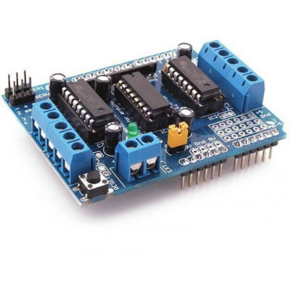
Fig 4.12 : Motor Driver Shield
4.7 USB
4.7.1 Introduction
Universal Serial Bus (USB) is an industry standard that establishes specifications for cables, connectors and protocols for connection, communication and power supply (interfacing) between computers, peripherals and other computers. A broad variety of USB hardware exists, including 14 different connector types, of which USB-C is the most recent.
First released in 1996, the USB standards are maintained by the USB Implementers Forum (USB-IF). The four generations of USB are: USB 1.x, USB 2.0, USB 3.x, and USB4. The connectors the USB committee specifies support a number of USB's underlying goals, and reflect lessons learned from the many connectors the computer industry has used.
4.7.2 USB Type – A Plug
The standard USB Type-A plug. This is one of many types of USB connector.

By design, it is difficult to insert a USB plug into its receptacle incorrectly. The USB specification requires that the cable plug and receptacle be marked so the user can recognize the proper orientation. The USB-C plug however is reversible. USB cables and small USB devices are held in place by the gripping force from the receptacle, with no screws, clips, or thumb-turns as some connectors use.
The different A and B plugs prevent accidentally connecting two power sources. However, some of this directed topology is lost with the advent of multi-purpose USB connections (such as USB On-The-Go in smartphones, and USB-powered Wi-Fi routers), which require A-to-A, B-to-B, and sometimes Y/splitter cables. USB connector types multiplied as the specification progressed. The original USB specification detailed standard-A and standard-B plugs and receptacles. The connectors were different so that users could not connect one computer receptacle to another. The data pins in the standard plugs are recessed compared to the power pins, so that the device can power up before establishing a data connection. Some devices operate in different modes depending on whether the data connection is made. Charging docks supply power and do not include a host device or data pins, allowing any capable USB device to charge or operate from a standard USB cable. Charging cables provide power connections, but not data. In a charge-only cable, the data wires are shorted at the device end, otherwise the device may reject the charger as unsuitable.
The USB system is very easy to use and really does not require any instructions for its use. However a few simple guidelines can help to ensure that it works well and does not cause any hiccups. Plug device in firmly: Make sure the device is firmly plugged in so that proper contact is made. Also as the USB plug is retained in the socket by friction, make sure it has been plugged all the way in so it does not fall out. Take care plugging in: Make sure the plug is the right way round. Sometimes it may need a careful look to make sure the USB plug is the right way round. Especially with the smaller connectors, USB mini and USB micro, it may not always be easy to see which way round it should be. Eject properly: With devices like memory sticks, make sure the device is ejected in the software before physically pulling it out. Be aware of current restrictions: USB ports can only supply a certain amount of current. Peripherals like external CD drives, or even other equipment may require relatively high levels of current and may not work if connected via an expander dongle. They may need to be connected directly into the computer port, etc.
Universal Serial Bus is a network of attachments connected to the host computer. These attachments come in two types known as Functions and Hubs. Functions are the peripherals such as mice, printers, etc. Hubs basically act like a double adapter does on a power-point, converting one socket, called a port, into multiple ports. Hubs and functions are collectively called devices.
Adoption of the USB 3.0 standard has been slow. Chip manufacturers must design motherboard hardware that supports USB 3.0. Computer owners have the option to purchase cards that they can install in their computers to give USB 3.0 support. But hardware support is just part of the problem -- you also need support from your operating system. Even though Microsoft announced that Windows 7 would eventually support the USB 3.0 standard, the company shipped its operating system without USB 3.0 support. Recent distributions of the Linux operating system support USB 3.0.
Serial ports, also called communication (COM) ports, are bi-directional. Bi- directional communication allows each device to receive data as well as transmit it. Serial devices use different pins to receive and transmit data -- using the same pins would limit communication to half-duplex, meaning that information could only travel in one direction at a time. Using different pins allows for full-duplex communication, in which information can travel in both directions at once.
Serial ports rely on a special controller chip, the Universal Asynchronous Receiver/Transmitter (UART), to function properly. The UART chip takes the parallel output of the computer's system bus and transforms it into serial form for transmission through the serial port. In order to function faster, most UART chips have a built-in buffer of anywhere from 16 to 64 kilobytes. This buffer allows the chip to cache data coming in from the system bus while it is processing data going out to the serial port. While most standard serial ports have a maximum transfer rate of 115 Kbps (kilobits per second), high speed serial ports, such as Enhanced Serial Port (ESP) and Super Enhanced Serial Port (Super ESP), can reach data transfer rates of 460 Kbps.

4.7.3 USB Standard Connectors
Available connectors by USB standard
Standard | USB 1.0  1996 | USB 1.1  1998 | USB 2.0  2001 | USB 2.0  Revised | USB 3.0 2008 | USB 3.1  2013 | USB 3.2  2017 | USB4 2019
Maximum transfer rate | 12 Mbps |  | 480 Mbps |  | 5 Gbps | 10  Gbps | 20  Gbps | 40  Gbps
Type A connector | 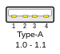 |  | 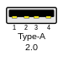 |  | 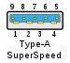 |  | Deprecated
Type B connector | 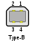 |  |  |  | 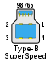 |  | Deprecated
Type C connector | N/A |  |  | 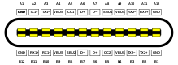  USB-C (Enlarged)
Mini-A connector | N/A | 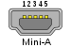 |  |  | Deprecated
Mini-B connector | N/A | 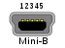 |  |  | Deprecated

Mini-AB connector | N/A | 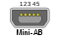 | Deprecated
Micro-A connector | N/A | 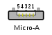 | 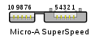 | Deprecated
Micro-B connector | N/A | 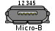 | 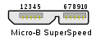 | Deprecated
Micro-AB connector | N/A | 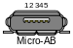 | 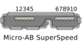 | Deprecated
        - The USB interface is self-configuring, eliminating the need for the user to adjust the device's settings for speed or data format, or configure interrupts, input/output addresses, or direct memory access channels.
        - USB connectors are standardized at the host, so any peripheral can use most available receptacles.
        - USB takes full advantage of the additional processing power that can be economically put into peripheral devices so that they can manage themselves. As such, USB devices often do not have user-adjustable interface settings.
        - The USB interface is hot-swappable (devices can be exchanged without rebooting the host computer).
        - Small devices can be powered directly from the USB interface, eliminating the need for additional power supply cables.
        - Because use of the USB logo is only permitted after compliance testing, the user can have confidence that a USB device will work as expected without extensive interaction with settings and configuration.
        - The USB interface defines protocols for recovery from common errors, improving reliability over previous interfaces.
4.7.4 USB 2.0

Fig 4.13 : High Speed USB Logo
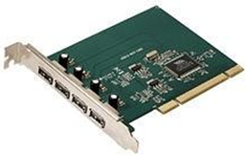
Fig 4.14 : A USB 2.0 PCI Expansion
USB 2.0 was released in April 2000, adding a higher maximum signaling rate of 480 Mbit/s
(maximum theoretical data throughput 53 MByte/s) named High Speed or High Bandwidth, in addition to the USB 1.x Full Speed signaling rate of 12 Mbit/s (maximum theoretical data throughput 1.2 MByte/s[).
Modifications to the USB specification have been made via engineering change notices (ECNs). The most important of these ECNs are included into the USB 2.0 specification package available from USB.org:

        - Mini-A and Mini-B Connector
        - Micro-USB Cables and Connectors Specification 1.01
        - InterChip USB Supplement
        - On-The-Go Supplement 1.3 USB On-The-Go makes it possible for two USB devices to communicate with each other without requiring a separate USB host
        - Battery Charging Specification 1.1 Added support for dedicated chargers, host chargers behaviour for devices with dead batteries
        - Battery Charging Specification 1.2: with increased current of 1.5 A on charging ports for unconfigured devices, allowing High Speed communication while having a current up to 1.5 A
        - Link Power Management Addendum ECN, which adds a sleep power state
        - USB 2.0 VBUS Max Limit, increased the maximum allowable V_BUS voltage from 5.25V to 5.50V to align with the USB Type-C Spec, which was released simultaneously.
        - Ice that relies on the USB standard requires minimal operator action. When a user plugs a device into a port on a running computer, it either entirely automatically configures using existing device drivers, or the system prompts the user to locate a driver, which it then installs and configures automatically.
The USB standard also provides multiple benefits for hardware manufacturers and software developers, specifically in the relative ease of implementation:

        - The USB standard eliminates the requirement to develop proprietary interfaces to new peripherals.
        - The wide range of transfer speeds available from a USB interface suits devices ranging from keyboards and mice up to streaming video interfaces.
        - A USB interface can be designed to provide the best available latency for time- critical functions or can be set up to do background transfers of bulk data with little impact on system resources.
        - The USB interface is generalized with no signal lines dedicated to only one function of one device.

The Universal Serial Bus is a network of attachments connected to the host computer. These attachments come in two types known as Functions and Hubs. Functions are the peripherals such as mice, printers, etc. Hubs basically act like a double adapter does on a power-point, converting one socket, called a port, into multiple ports. Hubs and functions are collectively called devices. Adoption of the USB 3.0 standard has been slow. Chip manufacturers must design motherboard hardware that supports USB 3.0. Computer owners have the option to purchase cards that they can install in their computers to give USB 3.0 support.

Software Requirements
4.8 Arduino IDE Compiler
The Arduino integrated development environment (IDE) is a cross-platform application (for Windows, macOS, Linux) that is written in the programming language Java. It is used to write and upload programs to Arduino compatible boards, but also, with the help of 3rd party cores, other vendor development boards.
The source code for the IDE is released under the GNU General Public License, version 2. The Arduino IDE supports the languages C and C++ using special rules of code structuring.The Arduino IDE supplies a software library from the Wiring project, which provides many common input and output procedures. User-written code only requires two basic functions, for starting the sketch and the main program loop, that are compiled and linked with a program stub main() into an executable cyclic executive program with the GNU tool chain, also included with the IDE distribution.^{[5]} The Arduino IDE employs the program argued to convert the executable code into a text file in hexadecimal encoding that is loaded into the Arduino board by a loader program in the board's firmware.
Arduino is a prototype platform (open-source) based on an easy-to-use hardware and software. It consists of a circuit board, which can be programmed (referred to as a microcontroller) and a ready-made software called Arduino IDE (Integrated Development Environment), which is used to write and upload the computer code to the physical board.
Arduino provides a standard form factor that breaks the functions of the micro-controller into a more accessible package.
Audience:

This tutorial is intended for enthusiastic students or hobbyists. With Arduino, one can get to know the basics of micro-controllers and sensors very quickly and can start building prototype with very little investment.
This tutorial is intended to make you comfortable in getting started with Arduino and its various functions.

Prerequisites:

Before you start proceeding with this tutorial, we assume that you are already familiar with the basics of C and C++. If you are not well aware of these concepts, then we will suggest you go through our short tutorials on C and C++. A basic understanding of microcontrollers and electronics is also expected. The Arduino IDE supports the languages C and C++ using special rules of code structuring. The Arduino IDE supplies a software library from the Wiring project, which provides many common input and output procedures. User-written code only requires two basic functions, for starting the sketch and the main program loop, that are compiled and linked with a program stub main() into an executable cyclic executive program with the GNU tool chain, also included with the IDE distribution. The Arduino IDE employs the program to convert the executable code into a text file in hexadecimal encoding that is loadedinto the Arduino board by a loader program in the board's firmware.

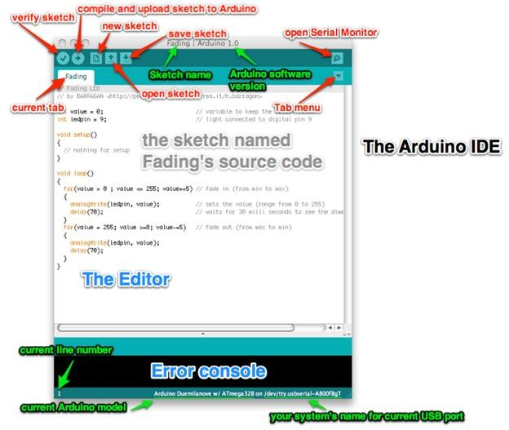
Fig 4.15 : Arduino IDE Editor
To begin, download the Arduino IDE from the Arduino website. Make sure to select the right version for your Operating System (OS). For a full getting started guide for each OS, please refer to the Arduino guide. Once the arduino.zip file has been downloaded, extract the file to a folder somewhere on your computer. There is no install - simply open the folder and double click the .exe. Modern, fully featured development environment Dual Mode, Classic Mode (identical to the Classic Arduino IDE) and Pro Mode.
4.9 Python
Python is a high-level, interpreted, general-purpose programming language.
Its design philosophy emphasizes code readability with the use of significant indentation.

Python is dynamically-typed and garbage-collected. It supports multiple programming paradigms, including structured (particularly procedural), object-oriented and functional programming. It is often described as a "batteries included" language due to its comprehensive standard library. Guido van Rossum began working on Python in the late 1980s as a successor to the ABC programming language and first released it in 1991 as Python 0.9.0.Python 2.0 was released in 2000 and introduced new features such as list comprehensions, cycle-detecting garbage collection, reference counting, and Unicode support. Python 3.0, released in 2008, was a major revision that is not completely backward- compatible with earlier versions. Python 2 was discontinued with version 2.7.18 in 2020. Python consistently ranks as one of the most popular programming languages.

4.9.1 Development Environment
Most Python implementations (including CPython) include a read– eval–print loop (REPL), permitting them to function as a command line interpreter for which users enter statements sequentially and receive results immediately.
Python also comes with an Integrated development environment (IDE) called IDLE, which is more beginner-oriented.
Other shells, including IDLE and IPython, add further abilities such as improved auto- completion, session state retention and syntax highlighting.
As well as standard desktop integrated development environments, there are Web browser- based IDEs, including SageMath, for developing science- and math-related programs; PythonAnywhere, a browser-based IDE and hosting environment; and Canopy IDE, a commercial IDE emphasizing scientific computing.The purpose of a development environment is to have a place for a developer to test anything they want without worrying about it affecting any end-users or content editors working on a live website. In most cases, a development environment is set up on a local machine or server, where the website’s source code is downloaded, so it is ready to be changed and modified. To help with the development process an integrated development environment (IDE) is often used to speed up the process and make a developer more productive.
4.9.2 Advantages of Python
        - Easy to Read, Learn and Write. Python is a high-level programming language that has English-like syntax.
        - Easy to use and learn: For beginners, Python is straightforward to use. It is a high-level programming language, and its syntax is like the English language. These reasons make the language easy to learn and adapt to. Compared to Java and C, in Python, the same task can be performed using fewer lines of code. As a result of its easy learning, the principles in Python can be executed faster compared to other languages.
        - Increased productivity: Python is a very productive language. The simple nature of Python helps the developers to concentrate on solving the issues in it. To understand the syntax and behavior of the programming language, the users do not have to spend hours, so more work is done.
        - Improved Productivity. Python is a very productive language.
        - Interpreted Language.
        - Dynamically Typed.
        - Free and Open-Source.
        - Portability

CHAPTER 5
RESULT ANALYSIS
5.1 Working
- Python script with open cv to track the robot with colour and used mathematics formulas to triangulate the colour boxes on the robot to find the position and orientation of the robot.
- There after we have used the python requests module to send the respective commands to navigate the robot from the pc.
- single camera is used to track robot.
- The pc will send the commands to Robot through wifi.
- Based on the signal send to the robot the robot will move according to the instructions.
- Finally, it drops the packages in respective places according to the instructions.
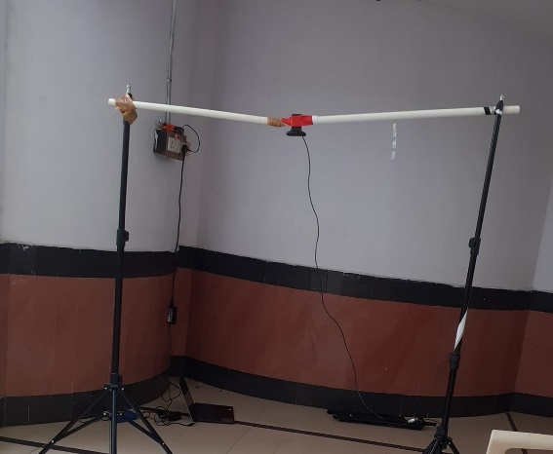
Fig 5.1 : Camera setup
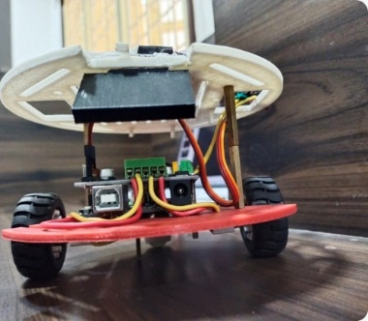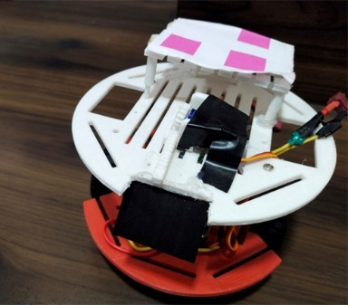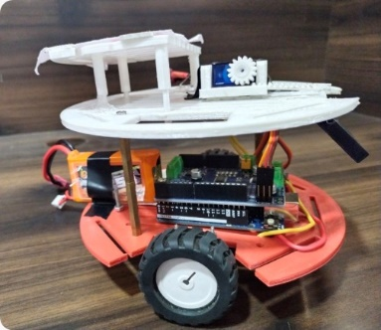
Fig 5.2 : Robots

5.2 GitHub Link for Code
The below link is the GitHub link for the respective Python and Arduino Codes
https://github.com/NeelimaTumpala/ENHANCED-AUTONOMOUS-ROBOT-WITH-CENTRAL-NAVIGATION-SYSTEM
5.3 Result
As a result the robots will move to respective places and drop the packages
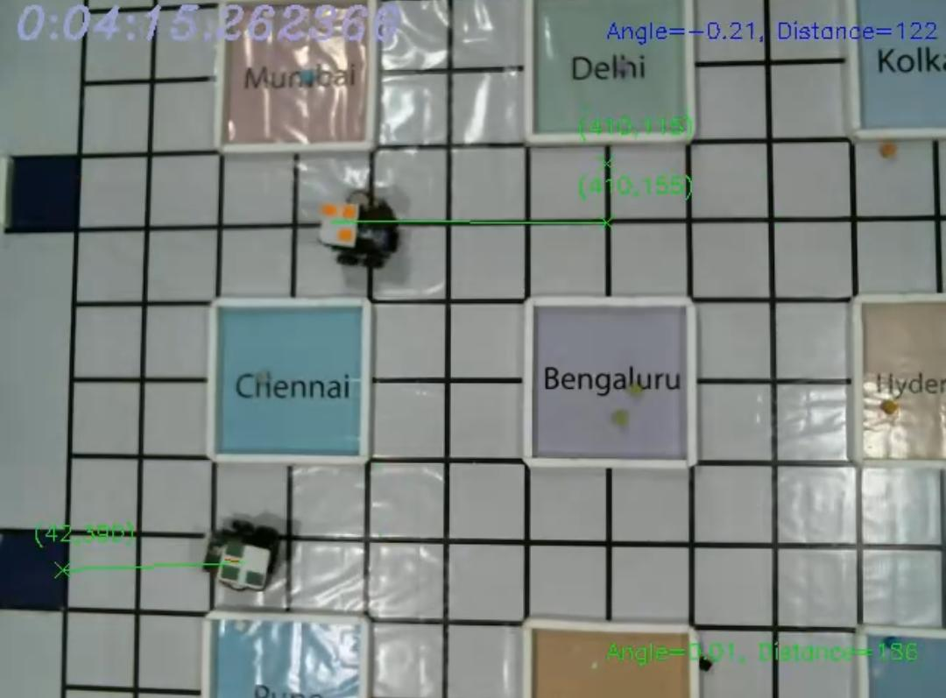
Fig 5.3 : Final Output
Output Video link :
https://drive.google.com/drive/folders/1pjhiv11Ug9HJ3ijLYu3C3nzmqt5YXYsM?usp=sharing

CHAPTER 6
Conclusion and Future scope

6.1 Conclusion
- The camera is continuously monitored the robot and assigned the path based upon the software instructions.
- The pc sent the commands to Robot through WIFI.
- Navigated the robot using Arduino Uno Wi-Fi Rev2 Board and delivered the objects form source to destination quickly with in the effective manner with most accuracy without using the sensors.
- Hence, with autonomous robot we have successfully delivered the packages from source to destination.

6.2 Future Scope
In the process of development of the robot most of the useful feature is identified and many of them was implemented. But due to the time limitations and other factor some of these cannot be added.
So the development features in brief : Use of color sensor.
There is no denying that Robotic technologies are all set to change the way things are done in the industries in which they are being implemented. Entrepreneurs are voicing a similar sentiment and are clearly optimistic about the use of Robotics in various industrial segments. Robotics is mainly capturing industries like manufacturing, pharmaceutical, FMCG, packaging and inspection.

References
- J. Warren, J. Adams and H. Molle, "Arduino for Robotics," in Arduino Robotics, New York, Apress publiction, 2014, pp. 51-83.

- Jim, "PWM/PID/Servo Motor Control," 2005. [Online]. Available: http://www.uoxray uoregon.edu. [Accessed 15 December 2015].

- Komonya, S. Tachi, K. Tanie, "A Method for Autonomous Locomotion of .Mobile Robots,''in Journal of Robotics Society of Japan, vol. 2, pp.222-231, 1984.

- S. Monk, Programming Arduino Getting Started with Sketches, New Delhi, India: Tata Macgrawhill, 2012.

- Open Source community, " Open Source Sketch," January 2015. [Online]. Available: https://www.arduino.cc/en/Guide/Introduction. [Accessed 25 November 2015].

- A. Parsad, "Line Following Robot,"Dept. Elex. & Comm. Eng., Visvesvaraya Technological University, Banglore, India, 2005

